Breaking the Speed Limit: The Art of Parallel Execution for Faster AI Agents
A. P. P. N. Gunathilake
Registration No: 2022/CSC/011
3rd Year Undergraduate, Department of Computer Science, University of Jaffna

Today, artificial intelligence is evolving beyond traditional conversational systems into autonomous AI agents capable of reasoning, making decisions, and taking actions independently. Modern AI agents can browse the web, write and execute code, query databases, and manage complex software workflows. However, when you assign a comprehensive research task to an AI agent, you may find yourself staring at a spinning loading indicator for several minutes. A task that a human researcher might complete in three minutes could take an AI agent ten minutes or more. Does this mean the AI model's thinking has become slower? Not necessarily. The problem may not lie in the model's computational ability, but in how the agent executes its tasks: its execution architecture.
Many AI agent workflows execute tasks sequentially, completing one operation before moving on to the next. However, by applying parallel execution concepts from modern distributed software engineering, we can significantly reduce these delays. To understand this concept, let's first look at an analogy from our everyday lives. Think for a moment about crossing a busy street. What would happen if your biological senses and essential body functions operated in strict, sequential order?
- First, your eyes would examine the road and identify approaching vehicles, but your ears would be unable to process any sounds until your visual processing was complete.
- Next, your eyes would stop processing visual information so your ears could listen to approaching vehicles and warning horns.
- Then, your visual and auditory systems would stop working while your brain waited to process information about your body's position and balance.
- Finally, only after all these separate stages were completed would your brain send signals to your leg muscles to begin moving.
If human biology truly worked in this step-by-step manner, even crossing a road safely would become an enormous challenge. The human body is nature's remarkable parallel processing system.
- Eyes (Vision) - Continuously process visual information to estimate the speed, trajectory, and distance of approaching vehicles.
- Ears (Hearing) - Simultaneously detect horn sounds, engine noise, and other environmental signals.
- Proprioceptive & Vestibular Systems - Continuously provide information about body position, movement, head orientation, and balance.
- Autonomic Nervous System: Regulates involuntary functions such as heart rate, breathing, and digestion without requiring conscious control.
These sensory systems operate concurrently, transmitting electrical signals through interconnected neural pathways involving the brain and spinal cord. The nervous system integrates this information and coordinates appropriate motor responses, allowing your body to react rapidly to its surroundings.
Next, consider an experience familiar to every university undergraduate, the three-member group assignment. Suppose your lecturer asks your team to research a technical topic:
- Student A must search for academic research papers online.
- Student B must examine open-source implementations on GitHub.
- Student C must search for recent news, benchmarks, and industry statistics.
What happens if this team works sequentially?
- Student A goes to the library and spends 30 minutes searching, while Students B and C wait in the cafeteria doing nothing.
- Only after Student A returns can Student B begin, spending another 30 minutes while the other two wait.
- Finally, Student C takes another 30 minutes to complete their part.
In this simplified example, assume that each student takes 30 minutes to complete their assigned task and the team needs an additional 5 minutes to combine the findings.
This sequential workflow resembles a common implementation of the ReAct (Reasoning + Acting) pattern, where an agent reasons, performs an action, observes the result, and then decides what to do next. When implemented without parallel tool execution, this process can introduce significant waiting time.
Next Through...
Action (Tool calling)
Waiting for Observation
Through
In computer science, the time spent waiting for a remote website, database, or API to respond over a network is associated with I/O latency. In tool-using AI agents, this waiting time can become a major bottleneck, particularly when tasks are executed sequentially. If all three students open their laptops simultaneously, they can gather information in parallel for 30 minutes and spend the final five minutes combining their findings into a unified report. In this scenario, the total time drops from 95 minutes to just 35 minutes.
Think of an AI agent as an intelligent team leader managing a three-member university group. Instead of assigning independent research tasks to three human students, the AI agent delegates those tasks to three different tools. Each tool handles a specific task independently, and once all the tools return their results, the AI agent combines them into a single, well-organized response.
To understand how software engineers implement this concept in real-world AI systems, let us follow a research scenario and build an Autonomous Academic Research Agent tasked with producing a comprehensive literature review on "Parallel AI Agent Architectures".
1. Single-Turn Multi-Tool Calling
The agent needs to gather information from three independent sources:
A - arXiv: Academic research papers and theoretical approaches.
B - Industry Benchmarks: Empirical performance data, latency measurements, and throughput comparisons.
C - GitHub Repositories: Open-source implementations, frameworks, and practical code examples.
Instead of querying these sources one by one, the agent can initiate all three requests within a single LLM response turn. This is the foundation of Single-Turn Multi-Tool Calling.

- Sequential Execution:
Fetch A
Fetch C
LLM Turn 2
Fetch B
LLM Turn 3
LLM Turn 1

Answer
LLM Turn 4

Let (T1), (T2), and (T3) represent the time required to receive responses from Fetch A, B, and C, respectively. Let (L) represent the duration of one LLM round-trip. Since the agent executes each tool call sequentially and requires a final LLM interaction to generate the answer, the approximate total execution time can be expressed as, T1+T2+T3+ 4L.
- Parallel Execution:
Fetch A
Answer
LLM Turn 2
LLM Turn 1
Fetch B

Fetch C

In this approach, all three independent tool calls execute concurrently. Therefore, the total execution time is determined by the slowest task, followed by the final LLM interaction that synthesizes the results. The approximate execution time can be expressed as max (T1, T2, T3) + 2L
Many modern LLM APIs support multiple tool calls within a single response turn. Once the agent identifies independent tasks, it can issue these tool calls together. On the application side, Python's asyncio.gather() can run multiple asynchronous operations concurrently and wait for their results, rather than awaiting each operation one after another.
- Reduced I/O Waiting: Independent tool calls execute concurrently, reducing the total waiting time compared with sequential execution.
- Fewer LLM Turns & Lower Costs: Combining independent tool calls into fewer LLM interactions can reduce the number of model roundtrips and associated inference overhead. Depending on the API and token usage, this may also reduce overall costs.

2. Directed Acyclic Graphs (DAG) and Fan-Out / Fan-In Pipelines
For complex multi-step workflows, modern agent frameworks such as LangGraph, AutoGen, and CrewAI provide orchestration capabilities that help developers coordinate tasks, manage dependencies, and execute independent operations concurrently. These workflows can be represented using a Directed Acyclic Graph (DAG), where nodes represent tasks and edges represent dependencies.
- Planner / Orchestrator: Analyzes the user’s request and breaks it into independent subtasks.
- Fan-Out (Scatter): Assigns those independent subtasks to separate worker nodes simultaneously.
- Synchronization Barrier: Waits until all required parallel tasks have completed before allowing dependent tasks to proceed.
- Fan-In (Gather): Merges all worker outputs like the brain integrating signals from multiple senses to produce the final answer.
The following Python implementation demonstrates a Fan-Out / Fan-In architecture using LangGraph. In this benchmark, three independent worker nodes (arXiv, Benchmarks, and GitHub) simulate querying external APIs Images 1.1-1.5 show the LangGraph Fan-Out/Fan-In implementation in parallel_agent.py, while Images 2.1-2.3 show the benchmark comparison script in run_comparison.py.
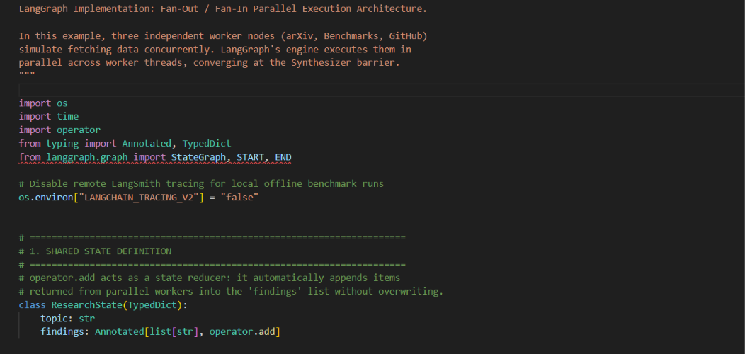
[image 1.1: library import and shared state]

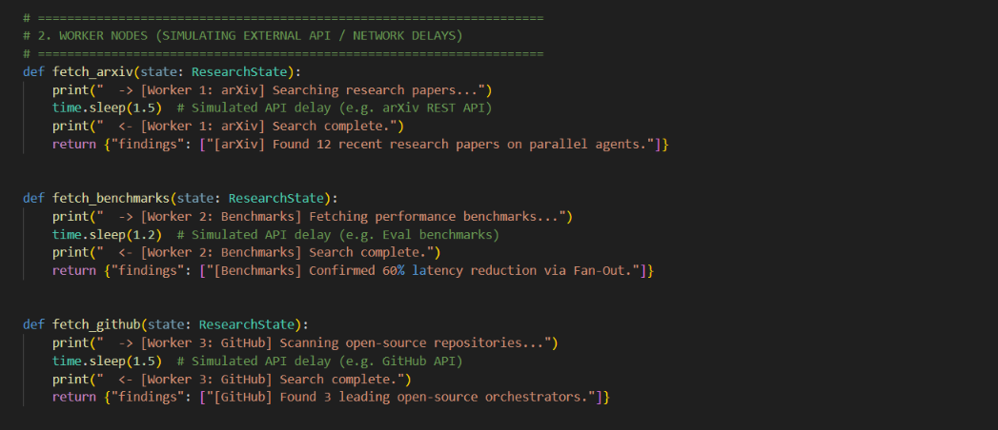
[image 1.2: Worker Nodes]
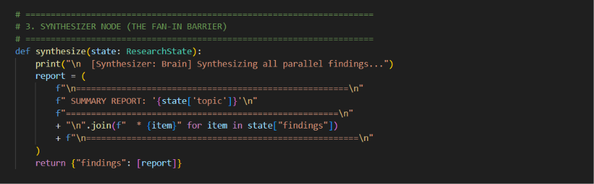
[image 1.3: Fan-in Synthersizer Node]

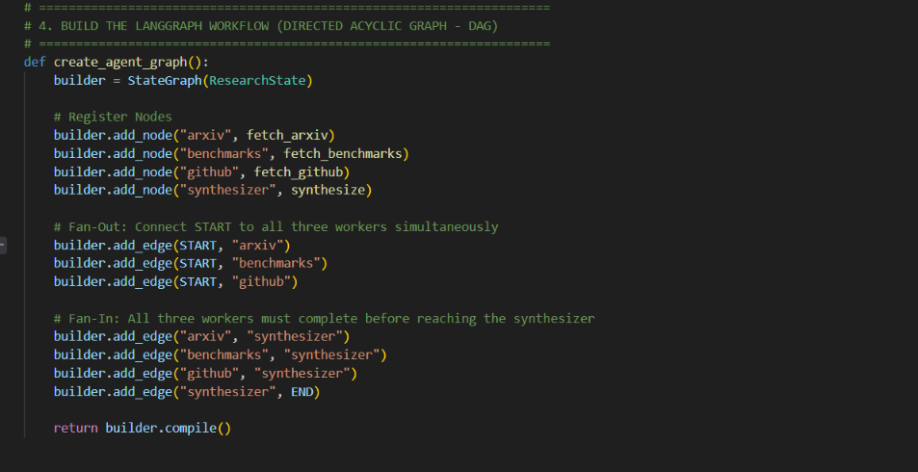
[image 1.4: LangGraph DAG Agent]
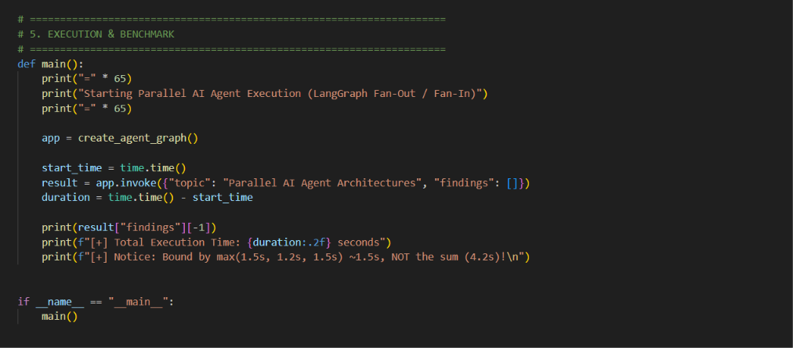
[image 1.5: Parelle Agent Execution Function]

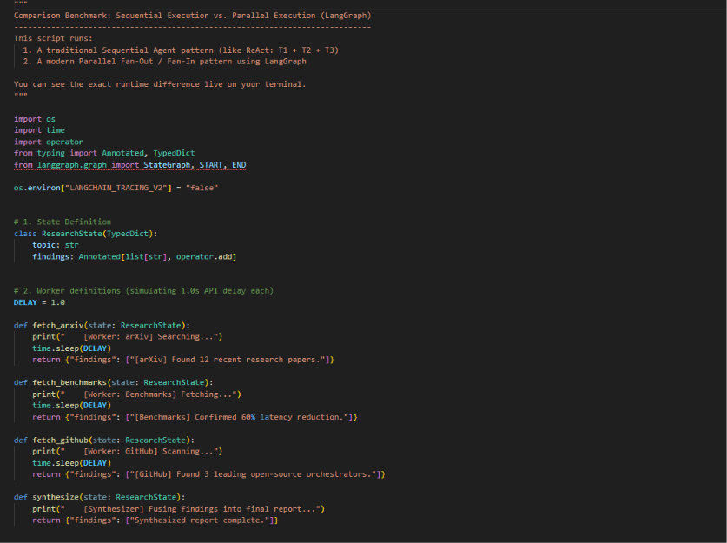
[image 2.1]

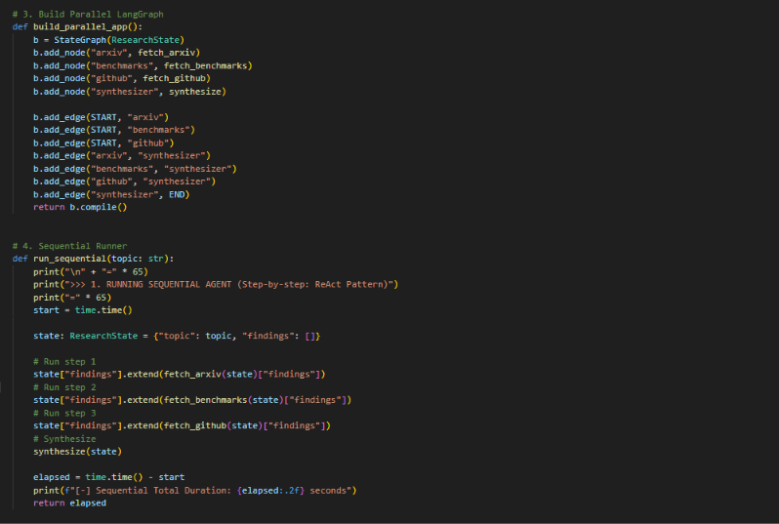
[image 2.2]

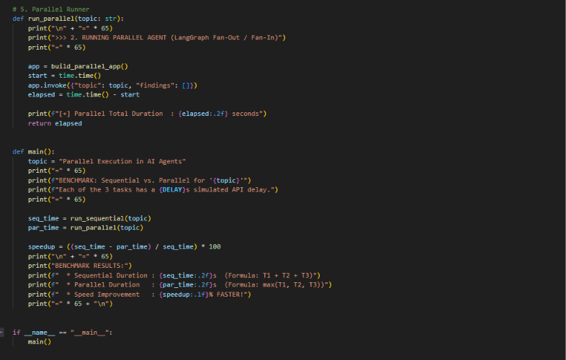
[image 2.3]
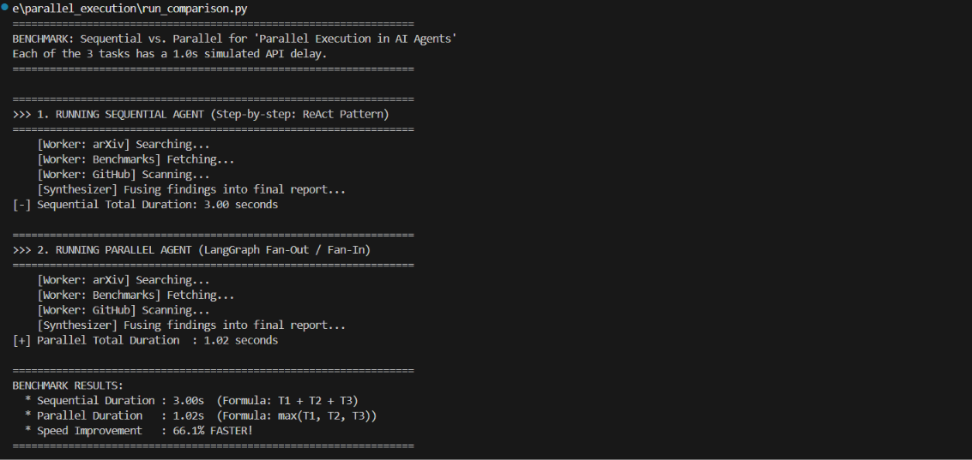
[image 3: Benchmark Results]

By executing the three independent tasks concurrently, the total runtime is primarily determined by the slowest task rather than the sum of the individual execution times. Across multiple benchmark runs under the same simulated conditions, the parallel implementation consistently achieved an execution-time reduction of approximately 66%. This demonstrates that, for independent tasks, the Fan-Out / Fan-In architecture can significantly reduce execution time compared to sequential execution.
3. Multi-Agent Swarms: Sectioning and Voting
As highlighted in Anthropic’s Building Effective Agents, parallelism is not limited to network calls. It can also be applied to cognitive parallelism using multiple AI models to reason simultaneously:
- Sectioning: A complex task is divided into smaller, independent subtasks that can be processed simultaneously. For example, while one model call prepares an answer to a user's request, another can evaluate the prompt for safety risks, compliance requirements, and organizational guardrails.
- Voting / Consensus: The same code snippet can be evaluated concurrently through multiple model calls using different prompts or approaches to identify potential security vulnerabilities. Comparing their findings can help improve the reliability of the assessment, although agreement does not guarantee correctness.
4. Speculative Tool Execution and Stream Pipelining
- Speculative Tool Execution: A lightweight model or prediction mechanism anticipates which tool calls an agent may need and starts preparing or executing them before the primary model has fully completed its decision. If the prediction is correct, this can reduce latency. However, incorrect predictions may waste computational resources or trigger unnecessary requests. Actions that modify external state should be carefully controlled or deferred until explicitly confirmed.
- Stream Pipelining: An upstream agent streams partial output as it becomes available, allowing downstream components to begin processing those results before the full response is complete. This can reduce end-to-end latency when the downstream task can work with partial input.

Six Essential Considerations for Parallel Execution
Parallel execution is not a universal solution. Before adopting it, software engineers must consider six critical trade-offs:
1. Check for Hidden Dependencies
Before running Task A and Task B in parallel, verify: “Do I already have all the inputs required for Task B before Task A returns its result?”
- Safe for Parallelism: Searching arXiv for academic research papers while independently exploring GitHub for open-source implementations related to "Parallel AI Agent Architectures". Both tasks can start immediately because neither depends on the results of the other.
- Must Run Sequentially: First, searching arXiv to identify a specific research paper and extract its title or DOI. Then, searching for that exact paper's implementation on GitHub. The second task depends on information obtained from the first task, so it must wait until Task A returns its results.
2. Understand the Difference Between Reads and Writes
- Read-only operations: Operations such as web searches, reading files, and checking prices can generally run concurrently because they do not modify external state. However, developers must still consider API rate limits and data consistency requirements.
- Write operations: Operations such as transferring money or modifying the same database record or code file can cause race conditions when executed simultaneously. In our LangGraph implementation, we use Annotated[list[str], operator.add] as a state reducer to combine worker findings in the shared findings state without overwriting previous results. However, this mechanism only manages LangGraph state updates; it does not protect external systems from conflicting writes.
3. Do Not Assume Results Arrive in Order
When dispatching multiple network requests simultaneously, do not assume that responses will arrive in the same order as the requests were sent. For example, if the third request is processed faster, its response may arrive before the first request. Always correlate each response with its original request using a unique identifier, such as a request ID or tool_call_id where supported, rather than relying solely on response order.
4. Handle Partial Failures and the Straggler Problem
If four tasks run in parallel, three may finish in one second while the fourth takes significantly longer due to network congestion or service delays. Because the Fan-In barrier waits for all branches to finish, a single slow task can delay the entire workflow.
- Mitigation: Set appropriate per-call timeouts based on the expected response time and the task's latency requirements. Implement graceful partial-failure handling so that the synthesizer can generate a response using the available results while clearly reporting any missing information.
5. Manage API Rate Limits and Context Window Bloat
- Limit Concurrency: Sending many requests concurrently can exceed a provider's rate limits and result in HTTP 429 (Too Many Requests) responses. Use an asyncio.Semaphore or worker pool to limit the number of simultaneous requests according to the provider's documented quotas.
- Avoid Context-Window Bloat: If multiple workers return large raw documents, passing all that unfiltered data to the synthesizer can increase token consumption and degrade reasoning quality. Workers should filter their results and return structured JSON or concise summaries whenever possible.

6. A Practical Guideline: Start Simple
Do not over-engineer multi-agent parallel swarms for problems that can be solved with a single direct prompt or a linear chain. Concurrency adds tracing and debugging complexity. Introduce it deliberately where clear I/O bottlenecks exist.

Developer’s Quick Checklist
Before turning any sequential agent workflow into a parallel pipeline, verify the following:
- Independence: Are the tasks truly independent, or do they depend on the intermediate outputs of other tasks?
- State Safety: Can the tasks safely access or modify shared state? If they perform writes, are appropriate concurrency control mechanisms in place?
- Resilience: Can the system handle timeouts, failed requests, and partial results gracefully?
- Rate Limits: Is concurrency controlled using mechanisms such as semaphores or worker pools to stay within API provider limits?
By following this checklist, developers can identify potential challenges before implementing parallel execution. Careful consideration of task dependencies, shared-state management, failure handling, and API limitations helps build more reliable, efficient, and scalable AI agent workflows.
Final Note: Intelligence and Speed Both Matter
In the early days of artificial intelligence, researchers primarily asked: “Is this model intelligent enough to solve this problem?” Today, as AI models continue to develop increasingly advanced reasoning capabilities, software engineers must also consider another important question: “How quickly, reliably, and efficiently can an AI agent perform tasks in real-world environments?”
Just as the human body coordinates multiple sensory systems and an efficient university project team handles independent tasks simultaneously, AI agents can achieve better performance through carefully orchestrated parallel execution. Identifying independent tasks, managing dependencies, and handling failures effectively are essential steps toward building reliable, efficient, and production-ready AI systems.

References & Further Reading
- Anthropic. “Building Effective Agents.” Anthropic Engineering, December 19, 2024. https://www.anthropic.com/engineering/building-effective-agents
- Zylos Research. “Speculative Execution and Parallel Tool Calling: Breaking the Sequential Bottleneck in AI Agents.” April 8, 2026. https://zylos.ai/research/2026-04-08-speculative-execution-parallel-tool-calling-ai-agents/

Source Code and Resources
The complete source code for the LangGraph-based implementation, including the benchmark scripts, is available below.
GitHub Repository: https://github.com/PasinduGunathilake/Newsletter-Article-Breaking-the-Speed-Limit-The-Art-of-Parallel-Execution-for-Faster-AI-Agents.git
Google Drive: https://drive.google.com/drive/folders/1WMM2DnHJFWa9m_s1hbFpjIsQJko9L5Oy?usp=sharing

